**Software Engineering**

**PROJECT DOCUMENTATION**

**FAST School of Management Sciences**

**NATIONAL UNIVERSITY OF COMPUTERS AND EMERGING SCIENCES**

**KARACHI CAMPUS**



**GROUP MEMBERS**

20k-0209 Muhammad Bilal

20K-0292 Muhammad Sohaib

20K-0151 Syed Nofel Talha

20K-0300 Abdul Wasay

**PROJECT TITLE:**

**MIGHTY RIDES**

**COURSE INSTRUCTOR:**

Miss Noureen Fatima

## INTRODUCTION

##### Project Background

##### The idea behind this project is to allow people to purchase cars of their choice online, , as well as it will allow customers to pre-book their orders for future (future scheduling). In addition to benefitting the customers, it makes job of car dealers easier, as they can list cars for sale within seconds.

##### Project Scope

##### The system has multiple User interfaces:

##### First interface is for the Dealer. The Dealer can sign up and create a personal account on the platform which he can use to list cars/car parts for sale and contact customers if they need help regarding any matter.

##### Second interface is the main interface the project focuses on: the customer’s interface. Here, a customer is allowed to create a customer account where he can explore all the cars on the platform or search cars and filter them, he can view their details and then proceed to buy it through a secure online transaction system.

##### Not In Scope

##### Not Applicable.

##### Project Objectives

##### This project will finally give customers to view listings from a diversity of dealers and get all purchases handled by secure transactions. In addition, customers can select how to customize all their products, which has not been a feature earlier.

##### It will also help people to work with us easily. It’s a free platform for car dealers to use to boost their sales.

##### These are the major objectives that were aimed and achieved by this project. Apart from that, the project helped us learn various strategies for solving the same problem.

## Technical Specifications

##### Functional Hierarchy

[This section will give a big picture of overall system functionality. The main modules/features of system and their sub-functions will be described here in the form of a functional hierarchy so that, before getting into the use case, audience could grab the idea of overall system functions.]

##### Use Cases

***4.2.1. [MightyRides Online Car trading platform]***

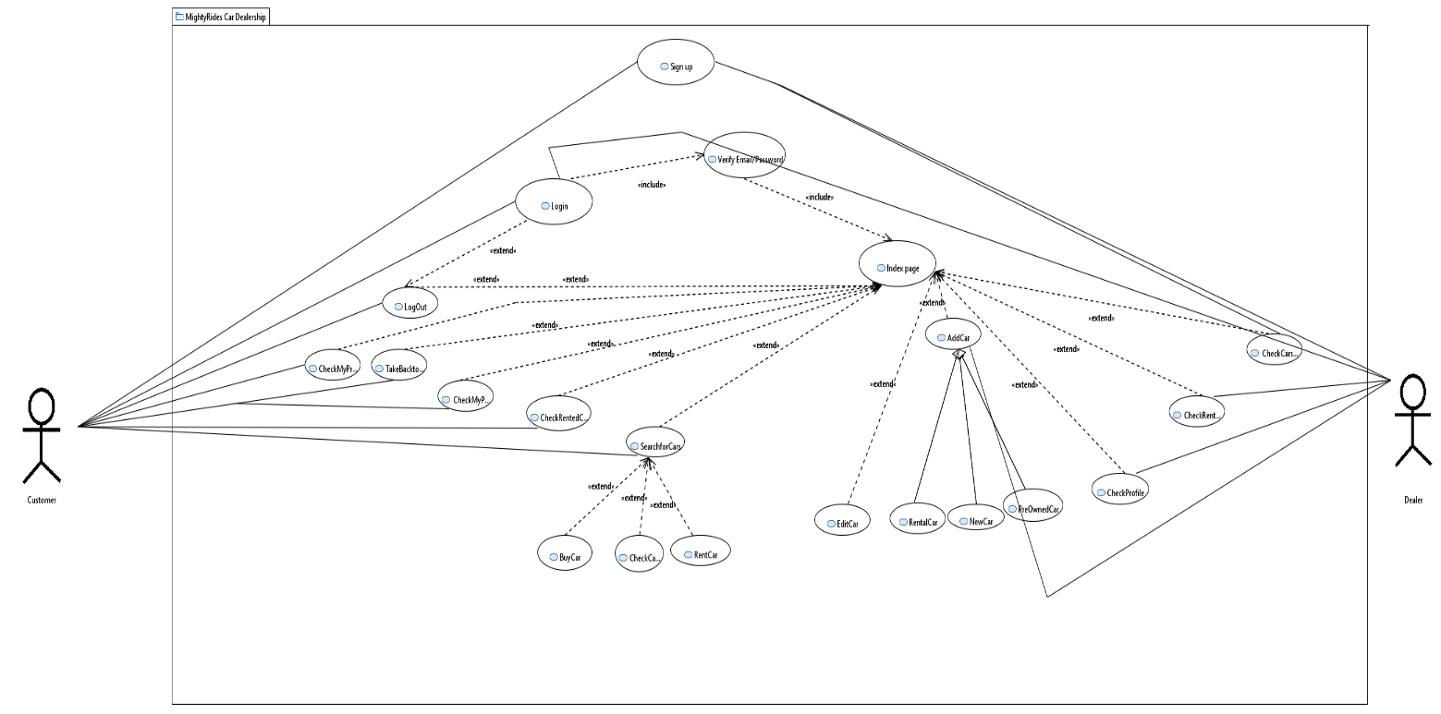

## Detailed System Design

## Class Diagram:

## 

## Functions:

## Customer:

## Signup – takes customer information, to register customer as a user.

## Login - takes customer information and verify the information from the database. If the information matches, customer information is loaded, which is used when the customer places order. It prevents asking for repeated information from the user.

## Add_to_cart – the customer adds car parts to his cart, this option is only available for car parts and not for cars themselves. product id is stored in the customer’s suborder.

## AddCustomization – allows the customer to customize his order.

## Checkout – allows the customer to finalize his / her cart, displays order summary, and places the order.

## Search – allow customer to search cars on various filters and requirements.

## Order:

## Display – shows order summary.

## Calculate_amount – calculates the final amount to be payed, after the discounts If offered by dealer.

## Checkout – order finalized, and placed.

## Card_info:

## Add – add credit / debit card information.

## Update - Update credit / debit card information.

## Verify – verifies card credentials.

## Billing:

## Generate_bill – generates bill with payable amount, and order summary.

## Get_cust_info – fetches customer data from customer id to use the information in printing the bill.

## Feedback:

## Get_review – allows customer/dealer to add a review regarding the working of the system so the developers can further enhance the experience.

## Dealer:

## Register – allows Dealer to register inputting some basic credentials.

## Add_car – allows Dealer to list rental/new/preowned cars.

## History:

## View– allows user to check their bought/sold/rented history.

## Time track – keeps track of rental times and informs customers on when they have to return cars..

## Category:

## Cartype : allows customer to select which type of car he is looking for.

## Car parts:

## Add – add car parts to cart.

## Update – update car parts.

## Car Compare:

## Compare–user can compare cars side by side to get a better comparison of them , helps in making better decisions..

## Suborder:

## Update_order – add items to order, as cart is updated.

## Admin:

## Login – takes login credentials from the admin, verifies it, and then allows access to the functions.

## Check_info – checking reviews.

### *Database Design*

**TECH STACK:**

FRONTEND:

* HTML
* CSS
* JAVASCRIPT
* BOOTSTRAP

BACKEND:

* PHP

DATABASE:

* MYSQL

STORAGE:

* Local storage

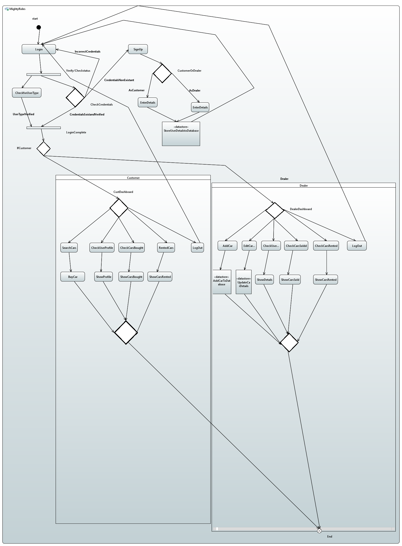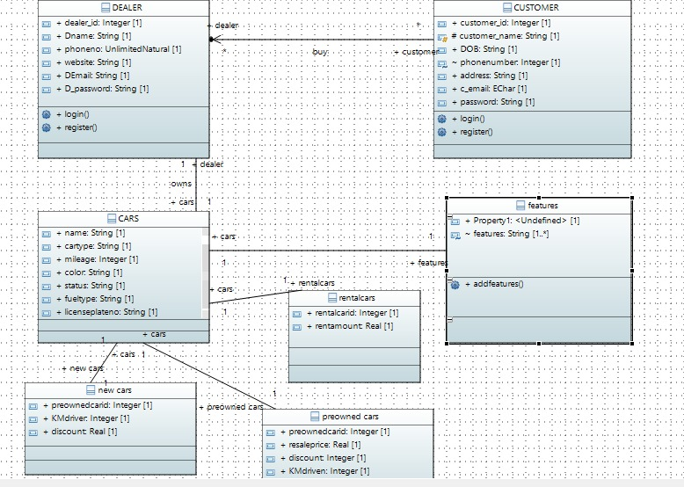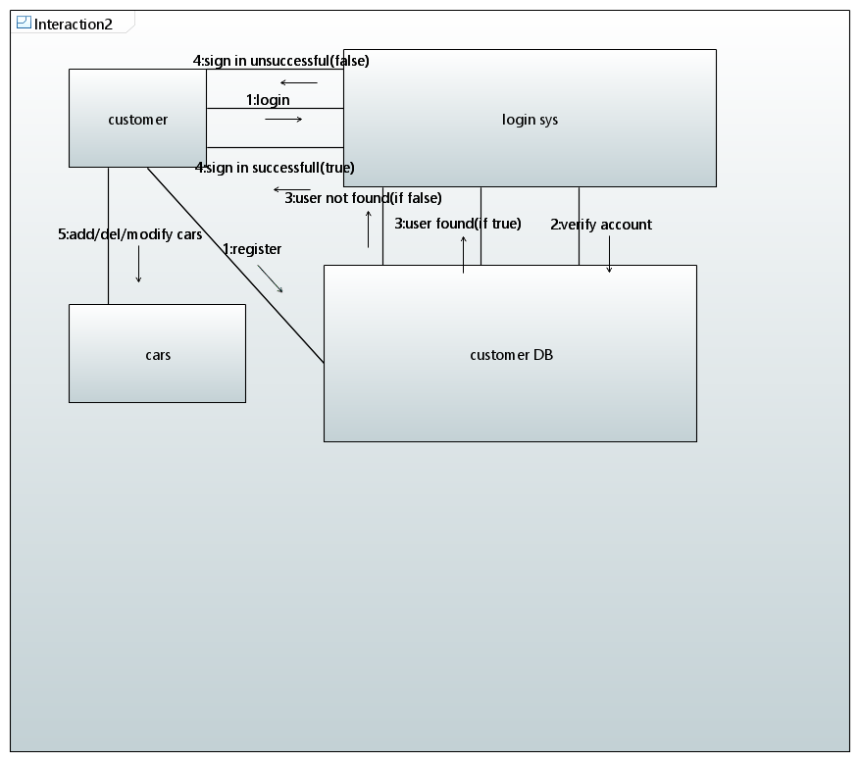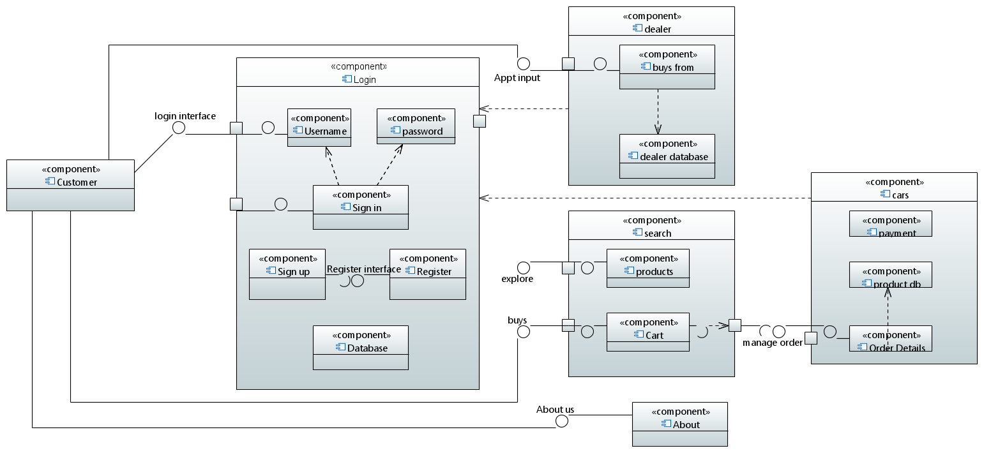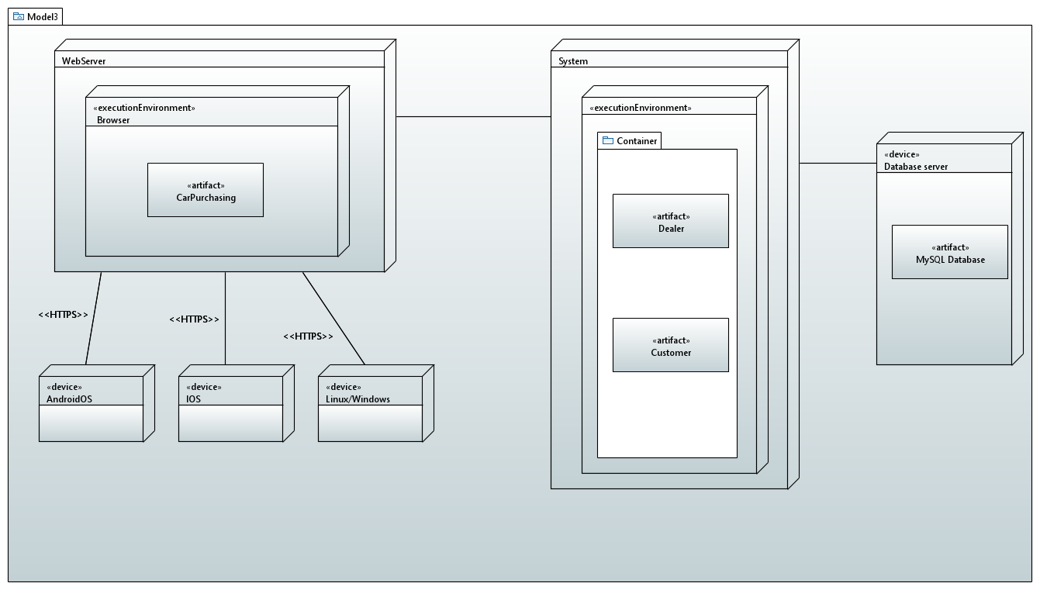

**Functional Requirements**

1. Vehicle listing: The website should allow car dealers to list their vehicles for sale with detailed information including make, model, year, mileage, features, and price.
2. Vehicle search: The website should allow users to search for vehicles by various criteria, such as make, model, year, mileage, features, and price range.
3. Booking and appointment scheduling: The website should allow users to book test drives and schedule appointments to view vehicles in person.
4. Vehicle comparison: The website should allow users to compare multiple vehicles side-by-side, based on specific features and prices.
5. Financing options: The website should offer financing options for users who wish to purchase vehicles through financing.
6. Payment and checkout: The website should provide a secure payment gateway to allow users to purchase vehicles online.
7. Vehicle history report: The website should provide vehicle history reports for each vehicle, detailing any accidents, repairs, or maintenance.

**Non-functional requirements :**

1. Usability: The website should be easy to use, with a clear and intuitive interface.
2. Performance: The website should be fast and responsive, with quick page load times and minimal downtime.
3. Security: The website should be secure, with appropriate measures to protect user data and financial transactions.
4. Accessibility: The website should be accessible to users with disabilities, including those who use assistive technology.
5. Scalability: The website should be able to handle a large volume of traffic and a growing number of users, without compromising performance or user experience.
6. Reliability: The website should be reliable, with minimal errors or downtime, and a robust backup and recovery system in place in case of any issues.
7. Mobile responsiveness: The website should be optimized for mobile devices, with a responsive design that adapts to different screen sizes and resolutions.

**Work Breakdown Structure (WBS)**

**1. Project Management**

1.1 Establish project scope, goals, and objectives.

1.2 Assign project roles and responsibilities.

1.3 Develop project timeline and milestones.

1.4 Track and monitor project progress.

1. **Design and Development** 
   1. Create website layout, functionality, and design.
   2. Develop front-end user interface.
   3. Develop back-end functionality.
   4. Implement user (buyer/dealer) registration and login system.
   5. Implement search system.
   6. Implement payment system.
   7. Implement messaging system.
   8. Implement listing management system.

1. **Testing and Quality Assurance** 
   1. Test website functionality and user experience
   2. Identify and resolve bugs and issues.
   3. Conduct user acceptance testing.
   4. Perform security testing and vulnerability assessment.
   5. Ensure compliance with relevant regulations and standards.

1. **Launch and Deployment** 
   1. Deploy website to production server.
   2. Conduct final testing and quality assurance.
   3. Go live with the website.

1. **Maintenance and Support** 
   1. Provide ongoing maintenance and support.
   2. Fix known bugs and improved functionality.

**Gantt Chart:**

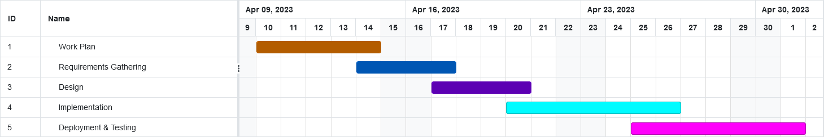

**Test Cases**

**Registration Test Case:**

Below is the test case for registering as a dealer or as a buyer

|  |  |  |  |  |  |  |  |  |  |  |
| --- | --- | --- | --- | --- | --- | --- | --- | --- | --- | --- |
| **Test Scenario ID** | | 1 | | | **Test Case ID** | | | T001 | | |
| **Test Case Description** | | Registration | | | **Test Priority** | | | HIGH | | |
| **Pre-Requisite** | | Active localhost connection | | | **Post-Requisite** | | | Login | | |
| Test Execution Steps: | | | | | | | | | | | |
| **S.No** | **Action** | | **Inputs** | **Expected Output** | | **Actual Output** | **Test Browser** | | **Test Result** | **Test Comments** | |
| 1 | Registration as Dealer | | Id: [xtrememotors@gmail.com](mailto:xtrememotors@gmail.com)  Pass: 12345678  Address: Defence | Dealer Registered | | Dealer Registered | Chrome | | Pass | Successful | |
| 2 | Registration as Buyer | | Id: [bilal@gmail.com](mailto:bilal@gmail.com)  Pass: 12345678  DOB: 01-01-2000  License: ABC12340972 | Buyer Registered | | Buyer Registered | Chrome | | Pass | Successful | |
|  |  | |  |  | |  |  | |  |  | |

**Login Test Case:**

Below is the test case for logging in as a dealer or as a buyer

|  |  |  |  |  |  |  |  |  |  |  |
| --- | --- | --- | --- | --- | --- | --- | --- | --- | --- | --- |
| **Test Scenario ID** | | 2 | | | **Test Case ID** | | | T002 | | |
| **Test Case Description** | | Login | | | **Test Priority** | | | HIGH | | |
| **Pre-Requisite** | | Dealer / Buyer is Registered | | | **Post-Requisite** | | | Dashboard | | |
| Test Execution Steps: | | | | | | | | | | | |
| **S.No** | **Action** | | **Inputs** | **Expected Output** | | **Actual Output** | **Test Browser** | | **Test Result** | **Test Comments** | |
| 1 | login as Dealer | | Id: [xtrememotors@gmail.com](mailto:xtrememotors@gmail.com)  Pass: 12345678 | Dealer logged in | | Dealer logged in | Chrome | | Pass | Successful | |
| 2 | login as Buyer | | Id: [bilal@gmail.com](mailto:bilal@gmail.com)  Pass: 12345678 | Buyer logged in | | Buyer logged in | Chrome | | Pass | Successful | |

**Listing a Car Test Case:**

Listing a car as a dealer

|  |  |  |  |  |  |  |  |  |  |
| --- | --- | --- | --- | --- | --- | --- | --- | --- | --- |
| **Test Scenario ID** | | 3 | | **Test Case ID** | | | T003 | | |
| **Test Case Description** | | Listing a New/Pre-Owned or Rental car | | **Test Priority** | | | HIGH | | |
| **Pre-Requisite** | | Dealer Logged In  Manufacturer listed in Database | | **Post-Requisite** | | | Redirects to Dealers Index page | | |
| Test Execution Steps: | | | | | | | | | | |
| **S.No** | **Action** | **Inputs** | **Expected Output** | | **Actual Output** | **Test Browser** | | **Test Result** | **Test Comments** | |
| 1 | Listing a new car | Manufacturer: BMW  Name: i8  Color: Orange  Manufacturer Date: 10-04-2023  Price: 80,000,000 PKR | Car is now listed | | Car is now listed | Chrome | | Pass | Successful | |
| 2 | Listing a pre-owned car | Manufacturer: Mercedes Benz  Name: AMG  Color: Grey  Manufacturer Date: 25-01-2023  Price: 180,000,000 PKR  License Plate: AAE-002 | Car is now listed | | Car is now listed | Chrome | | Pass | Successful | |
| 3 | Listing a pre-owned car with duplicate number | Manufacturer: Honda  Name: Civic 1.8 i-VTEC Oriel  Color: White  Manufacturer Date: 12-01-2021  Price: 6,000,000 PKR  License Plate: AAE-002 | Car is not listed | | Car is not listed | Chrome | | Pass | Successful | |
| 4 | Listing a rental car | Manufacturer: Toyota  Name: Corolla Altis Grande 1.8 CVTi  Color: White  Manufacturer Date: 17-09-2022  Price: 5000/HR  License Plate: ACE-212 | Car is listed | | Car is listed | Chrome | | Pass | Successful | |

**Setting Discount on a Car Test Case:**

Listing a car as a dealer

|  |  |  |  |  |  |  |  |  |  |
| --- | --- | --- | --- | --- | --- | --- | --- | --- | --- |
| **Test Scenario ID** | | 4 | | **Test Case ID** | | | T004 | | |
| **Test Case Description** | | Listing a New/Pre-Owned or Rental car | | **Test Priority** | | | Low | | |
| **Pre-Requisite** | | Car Listed | | **Post-Requisite** | | | Redirects to Dealers Index page | | |
| Test Execution Steps: | | | | | | | | | |
| **S.No** | **Action** | **Inputs** | **Expected Output** | | **Actual Output** | **Test Browser** | | **Test Result** | **Test Comments** |
| 1 | Setting a discount less than 5 | 4 | Discount not added | | Discount not added | Chrome | | Pass | Successful |
| 2 | Setting a discount greater than 90 | 95 | Discount not added | | Discount not added | Chrome | | Pass | Successful |
| 3 | Setting a discount within range 5-90 | 40 | Discount added | | Discount added | Chrome | | Pass | Successful |

**Cancelling an ongoing rent Test Case:**

Listing a car as a dealer

|  |  |  |  |  |  |  |  |  |  |
| --- | --- | --- | --- | --- | --- | --- | --- | --- | --- |
| **Test Scenario ID** | | 5 | | **Test Case ID** | | | T005 | | |
| **Test Case Description** | | Listing a New/Pre-Owned or Rental car | | **Test Priority** | | | Medium | | |
| **Pre-Requisite** | | Car Listed  Car Rented by Buyer | | **Post-Requisite** | | | Redirects to Dealers Index page | | |
| Test Execution Steps: | | | | | | | | | |
| **S.No** | **Action** | **Inputs** | **Expected Output** | | **Actual Output** | **Test Browser** | | **Test Result** | **Test Comments** |
| 1 | Cancel | Ok | Rent cancelled | | Rent cancelled | Chrome | | Pass | Successful |

**Buying/renting a Car Test Case:**

Buying/renting a car as a customer

|  |  |  |  |  |  |  |  |  |  |
| --- | --- | --- | --- | --- | --- | --- | --- | --- | --- |
| **Test Scenario ID** | | 6 | | **Test Case ID** | | | T006 | | |
| **Test Case Description** | | Buying/renting a New/Pre-Owned or Rental car | | **Test Priority** | | | HIGH | | |
| **Pre-Requisite** | | Cars must be listed by the dealer | | **Post-Requisite** | | | Redirects to customer Index page | | |
| Test Execution Steps: | | | | | | | | | | |
| **S.No** | **Action** | **Inputs** | **Expected Output** | | **Actual Output** | **Test Browser** | | **Test Result** | **Test Comments** | |
| 1 | Buying a new car | Buy now and credentials | Cars move to your inventory as bought cars | | Cars move to your inventory as bought cars | Chrome | | Pass | Successful | |
| 2 | Buying a pre-owned car | Buy now and credentials | Cars move to your inventory as bought cars | | Cars move to your inventory as bought cars | Chrome | | Pass | Successful | |
| 3 | Buying a pre-owned car with duplicate number | Buy now and credentials | Cars move to your inventory as bought cars | | Cars move to your inventory as bought cars | Chrome | | Pass | Successful | |
| 4 | Renting a rental car | Date of starting and end of rent. | Cars move to your inventory as rented car | | Cars move to your inventory as rented car | Chrome | | Pass | Successful | |

**Update profile Test Case:**

Updating profile of a customer/dealer

|  |  |  |  |  |  |  |  |  |  |
| --- | --- | --- | --- | --- | --- | --- | --- | --- | --- |
| **Test Scenario ID** | | 7 | | **Test Case ID** | | | T007 | | |
| **Test Case Description** | | Updating dealers/customer profile. | | **Test Priority** | | | MEDIUM | | |
| **Pre-Requisite** | | Cars must be listed by the dealer | | **Post-Requisite** | | | Redirects to page | | |
| Test Execution Steps: | | | | | | | | | | |
| **S.No** | **Action** | **Inputs** | **Expected Output** | | **Actual Output** | **Test Browser** | | **Test Result** | **Test Comments** | |
| 1 | Updating dealer/customer name | New name | New name updated | | New name updated | Chrome | | Pass | Successful | |
| 2 | Updating dealer/customer  DOB | NEW DOB | New DOB  updated | | New DOB updated | Chrome | | Pass | Successful | |
| 3 | Updating dealer/customer  Phone no | New phone no | New phone no updated | | New phone no updated | Chrome | | Pass | Successful | |
| 4 | Updating dealer/customer driving license no | New driving license | New driving license updated | | New driving license updated | Chrome | | Pass | Successful | |

Login/Sign up Page

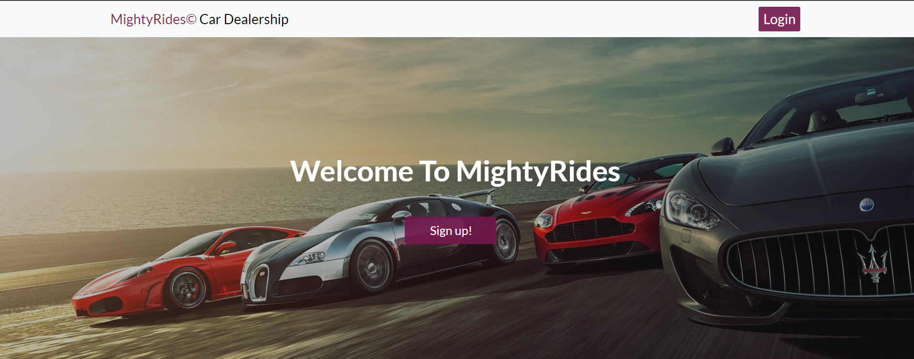

#### Customer Index Page

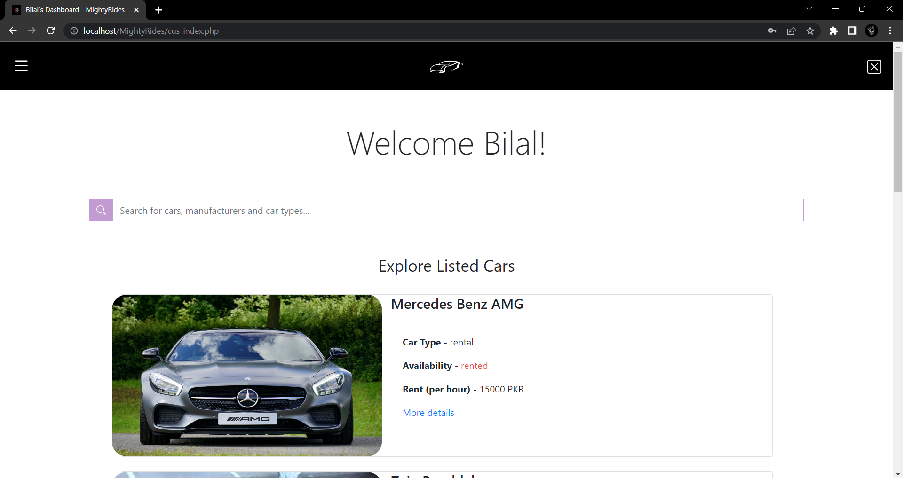

Search Functionality

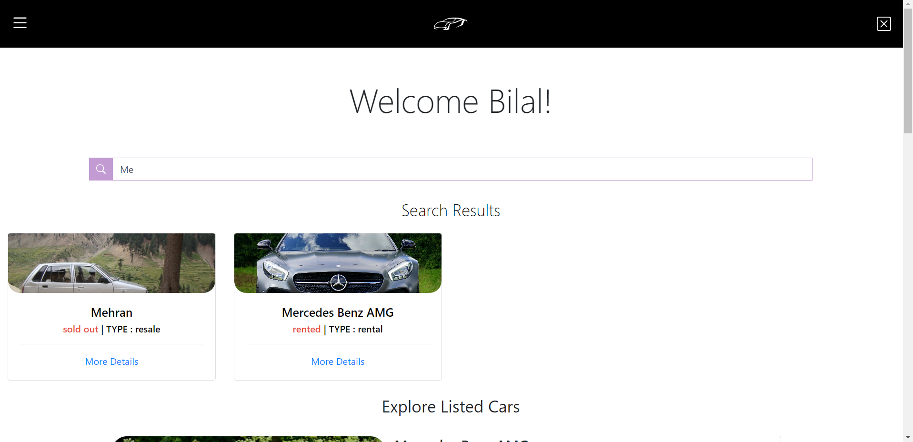

Customer Profile

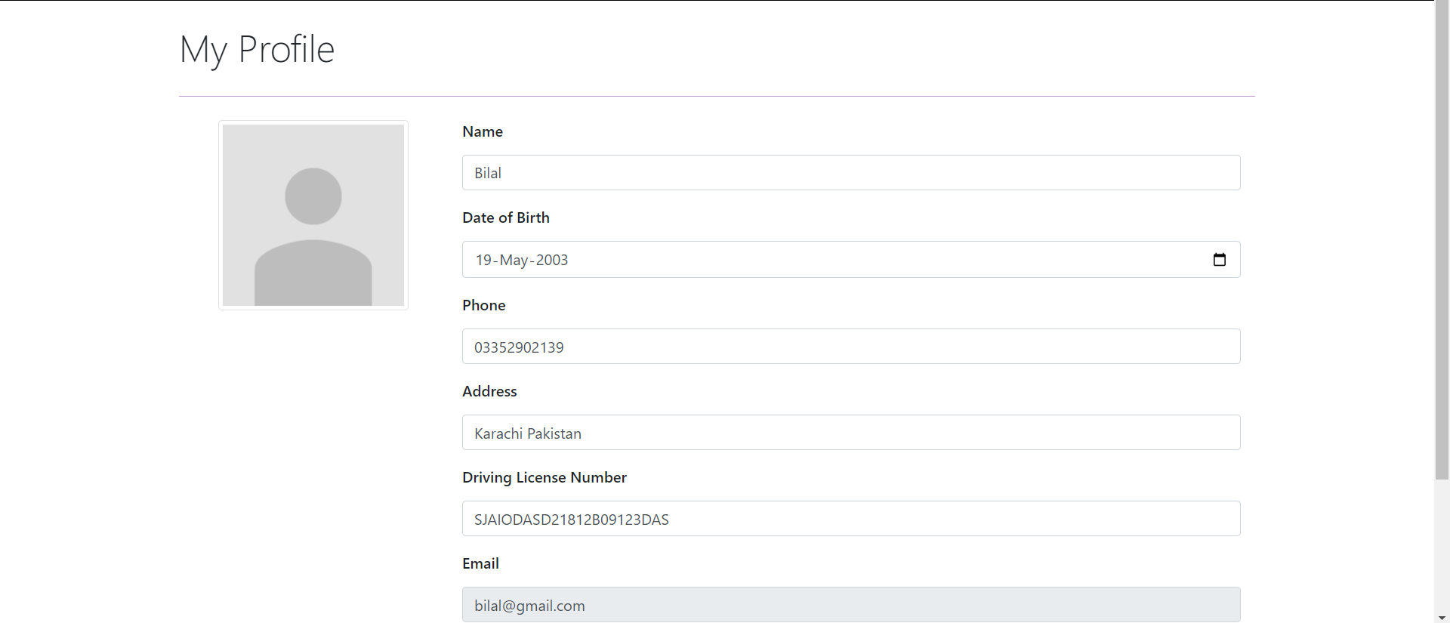

Cars Purchase History

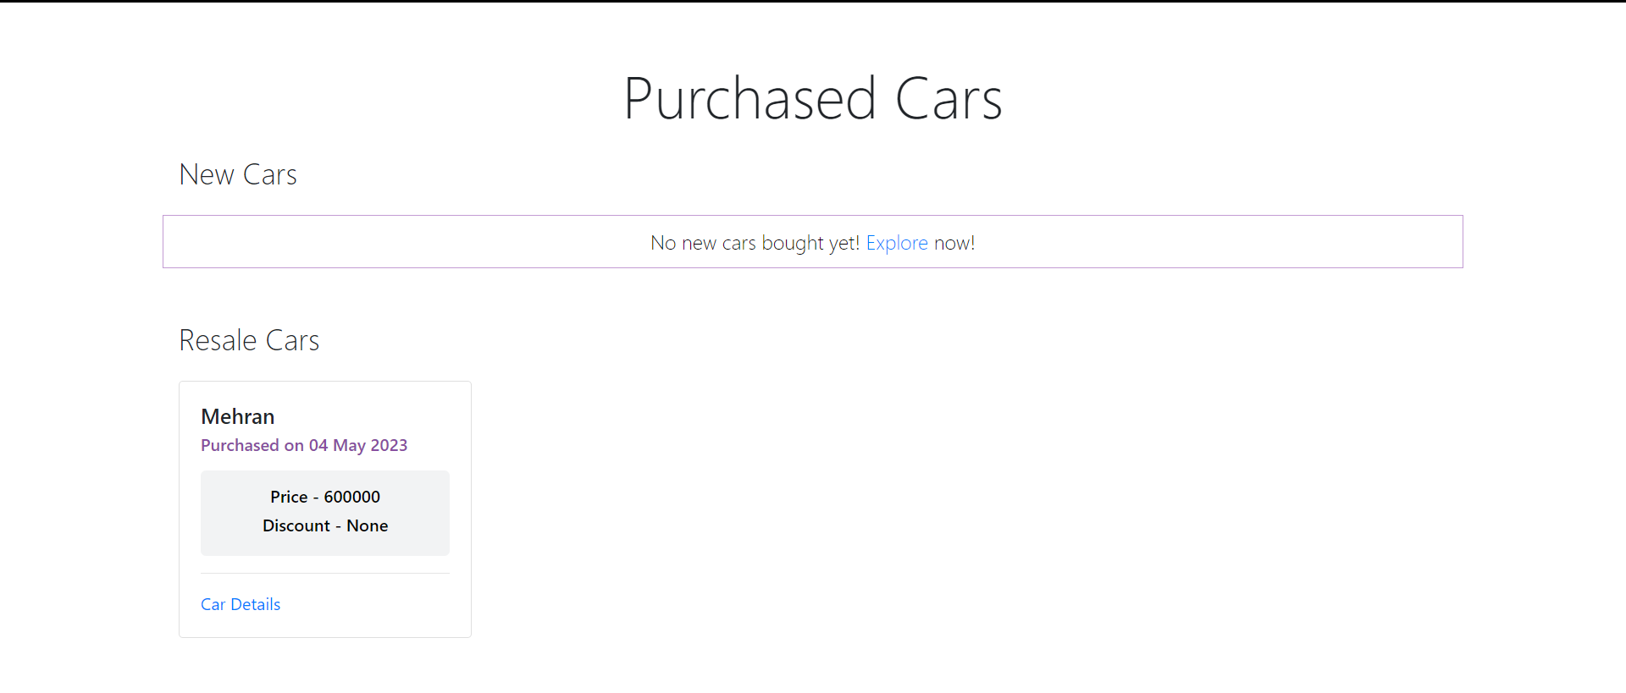

Dealer Index Page

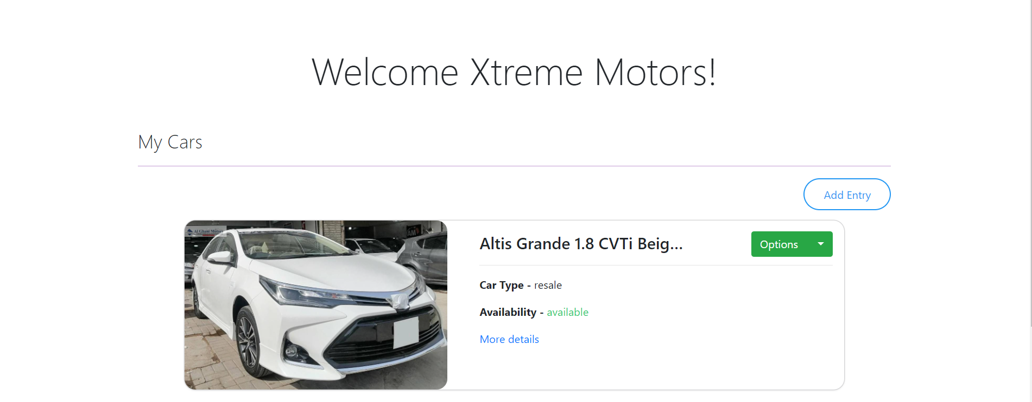

Listing a car

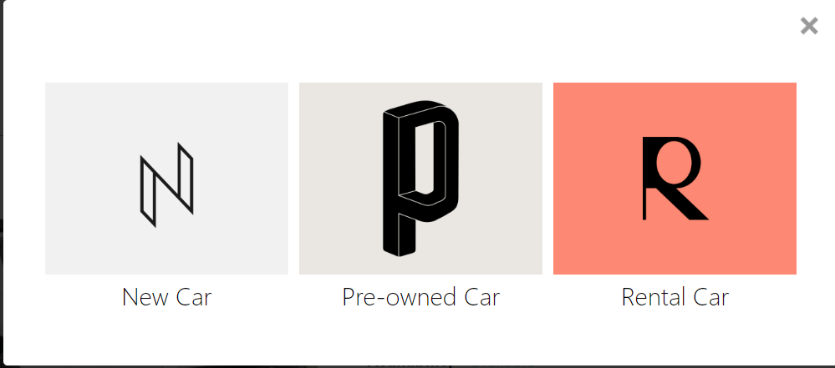

Car Form

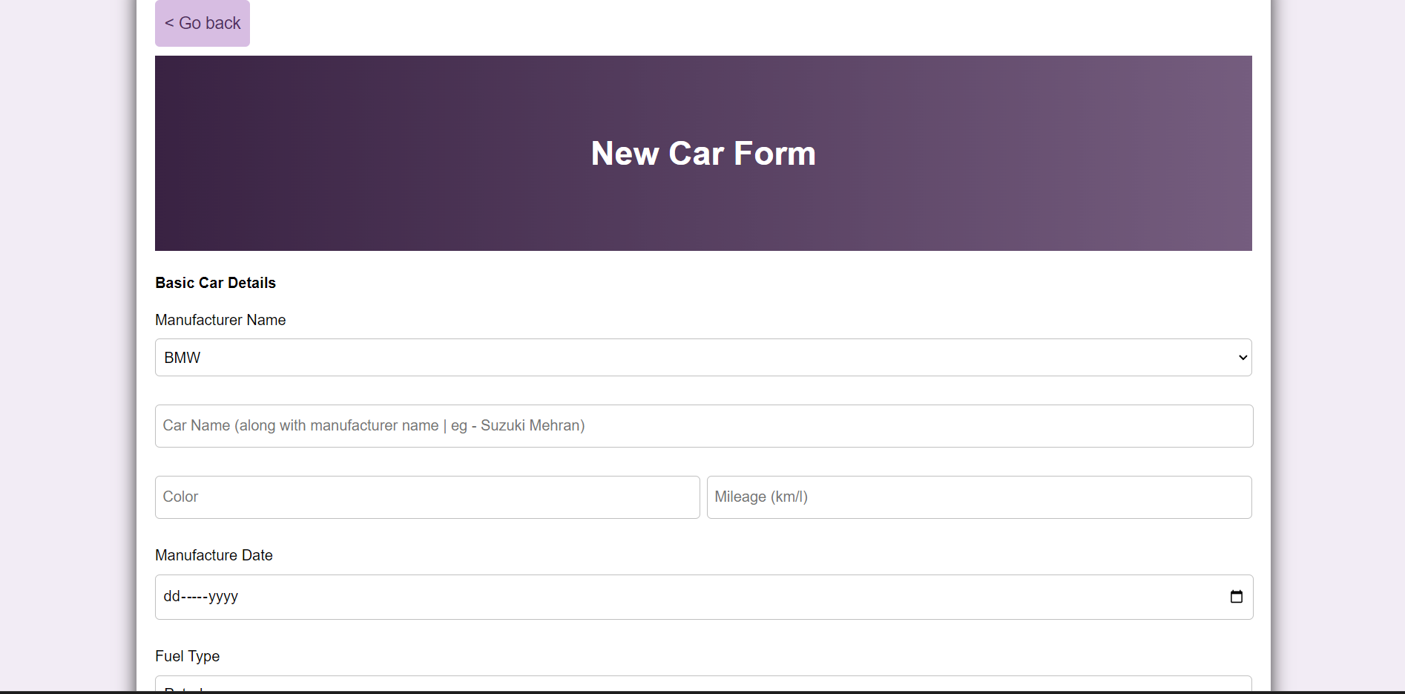

Cars Database

